

DESIGN OF A WEB APPLICATION -AS1

STUDENT NAME: Uqba Asghar

ASSIGNMENT / COURSE WORK: 1 OF 2

LEVEL: 4

WEIGHTING: 50%

TOTAL-MARKS: 100

Section 1

**VISUAL LAYOUT AND DESIGN**

HIGH LEVEL DESIGN:

High-level design (HLD) refers to the process of creating a conceptual and abstract representation of the software or system architecture. It involves defining the system's structure, modules, interfaces, and dependencies, among other elements.

HLD provides an overview of the system or software's functionality, the user interactions, and the data flow between various components. It is the initial step in software or system development, where the requirements are translated into an architecture that can be used as a basis for the subsequent implementation.

The high-level design should be detailed enough to communicate the design approach and strategy but should also be flexible enough to allow for changes and adjustments during the implementation phase. The design should adhere to the system requirements and take into consideration any constraints such as budget, time, and resources.

**DESCRIPTIVE**

A makeup website's goal and objective can change depending on its particular objectives and target market. Yet, a makeup website's goal and purpose can often be summarized:

1.Purpose:

A makeup website's primary function is to offer information and resources about makeup tools, methods, and trends. These are just a few typical uses for makeup websites:

1. Education: Makeup websites frequently work to inform users on makeup application methods, product ingredients, and how to pick the best products for various skin types and requirements.
2. Sales of products: Several makeup websites are made with the intention of selling makeup items, either directly through an online store or by linking to independent merchants.
3. Inspiration: To inspire and entice visitors to explore new styles and methods, makeup websites frequently provide instructions, photographs, and videos demonstrating various makeup looks.
4. Community: Several cosmetics websites provide a forum for makeup enthusiasts to interact, exchange advice, and talk about the newest trends in the field.

In general, the goal of a makeup website is to give knowledge and resources connected to makeup in order to educate, inspire, and engage visitors. Nevertheless, the exact purpose of a beauty website will differ based on the website in question and its target demographic.

2. Objective and Goals:

The objectives and goals of a makeup website can change based on the particular website and its target audience. In contrast, the following are some typical aims and objectives of makeup websites:

1. Information about makeup products: One of the main aims of a website dedicated to makeup is provide details on various makeup products, such as their features, advantages, and methods of application. Customers can use this information to make well-informed purchase decisions.
2. Selling makeup items: Selling makeup items directly to customers is another key goal of a makeup website. This can entail setting up an online store where clients can explore and make purchases.
3. To create a community: Many makeup websites want to create a community of makeup fans who can exchange tips, counsel, and product reviews. Consumers may feel more a part of the business as a result, increasing their loyalty.
4. To provide makeup tutorials and advice: Makeup websites might also include makeup tutorials and suggestions for how to apply makeup, which can be useful for newcomers or anyone wishing to enhance their application abilities.
5. To increase brand recognition: Makeup websites may also seek to increase brand recognition by exhibiting their goods and forging a distinctive brand identity through the layout, text, and social media presence of their websites.

In general, the major goal of a makeup website is to add value to its visitors by providing content, goods, and services that cater to their requirements and interests in the makeup industry.

# 3. Content of the Website:

Generally, makeup websites offer a variety of content about makeup and beauty, such as:

1. Product details: Information on various makeup products, including descriptions, ingredients, and usage guidelines, is often provided on makeup websites.
2. Tutorials: Makeup websites may include instructions on how to use various products, create particular makeup looks, and apply makeup for various occasions.
3. Reviews: Customers' feedback on various makeup items may be found on makeup websites, assisting shoppers in making wise judgments.
4. Beauty tips: Makeup websites may offer guidance and assistance on a variety of beauty-related subjects, including face products, lips products, cheeks products and eye products.
5. Posts on blogs: A lot of companies that sell makeup have blogs where they post news and updates on the newest makeup trends as well as other subjects pertaining to makeup and beauty.

A makeup website's material will probably be geared towards educating and inspiring readers about makeup and beauty in general.

4. Target Audience:

It is challenging to identify the target demographic without more details about the contested makeup website. The target market of a makeup website, however, might vary based on the brand and the products being offered. While some makeup businesses may have a narrower target audience that includes people of all ages and genders, others may have a target audience that is much broader and includes people of all demographics, such as teenagers, young adults, or mature ladies.

Moreover, elements like price range, product kind, and marketing technique may have an impact on a makeup website's target demographic. For instance, a high-end makeup line may target those with higher income levels, whereas a drugstore line might target people searching for inexpensive goods.

Therefore, it's critical for makeup websites to identify their target demographic in order to properly target their marketing efforts and product offerings.

# 5. Main Goal:

The major objective of a beauty website might vary based on the particular website in question, but generally speaking, the main objective is to supply its target audience with knowledge, products, and services relevant to makeup.

While some makeup websites focus more on offering educational materials like tutorials, product reviews, and beauty advice, others are more focused on selling makeup products to consumers directly.

The fundamental objective of a cosmetics website is to connect with those who are engaged in makeup and give them the knowledge, resources, and items they require to create their ideal appearance.

2) Wireframes:

A wireframe is a visual guide or blueprint that represents the skeletal framework of a website or application. It is a simple and basic representation of the layout of a webpage or screen, without any design elements, color, or typography. A wireframe can be hand-drawn or created using software tools, and it typically includes the main components of a webpage or application, such as the header, footer, navigation menu, content areas, and buttons.

A wireframe is used to help designers, developers, and clients communicate more easily and to give a clear grasp of the style and structure of a website or application. It helps to identify potential usability issues, clarify the user flow, and establish the hierarchy of information on the page. A wireframe is often created early in the design process, and it serves as a starting point for the visual design and development phases.

Following are the wireframes of my website:

* Home Page.
* Products Page
* About Page.
* Sign Up Page
* Contact Us Page.

1. **Mid Fidelity Designs:**

Mid-fidelity design is a design approach that falls somewhere between low-fidelity and high-fidelity design. It refers to a level of detail and refinement in design prototypes that is greater than low-fidelity but less than high-fidelity prototypes.

Mid-fidelity designs are typically more polished and visually appealing than low-fidelity prototypes, but not as fully fleshed out as high-fidelity prototypes. They might include some placeholder text or images, but they generally lack the level of detail and interactivity of high-fidelity designs.

Mid-fidelity designs are useful for exploring and refining design concepts, testing user interactions, and gathering feedback from stakeholders. They are often created using tools such as wire framing software or prototyping tools, and can be used to create a more tangible representation of a design concept than low-fidelity sketches or mockups.

1. Home Page.

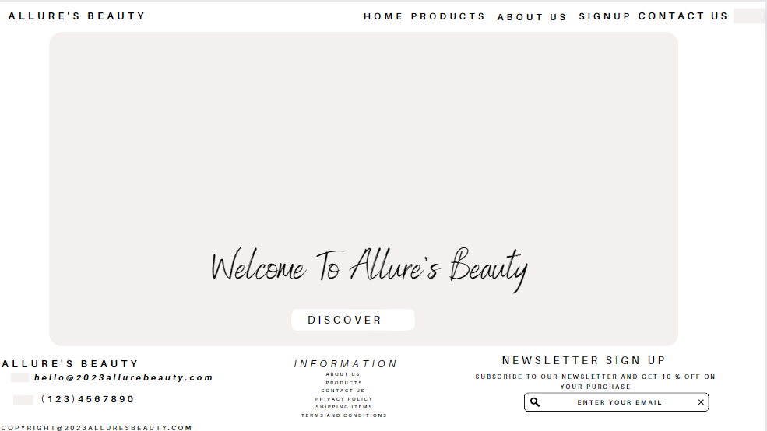

The home page will act as an introduction to the website and give a summary of the contents of my website. The header portion of the home page contains the website's logo and navigation menu.

The footer portion of the home page contains the information, newsletter sign up and contact.

2. PRODUCTS:

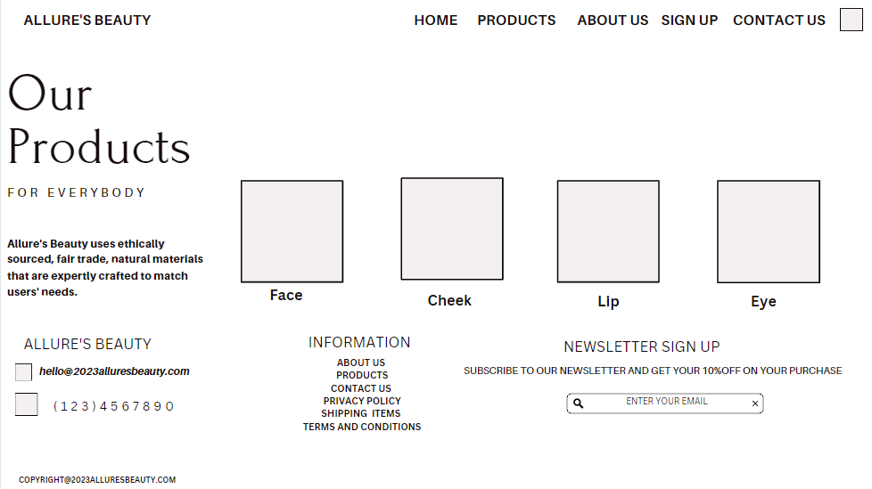  
In this wireframe , we are showing different makeup products for different parts of the face .

# 3. About Us:

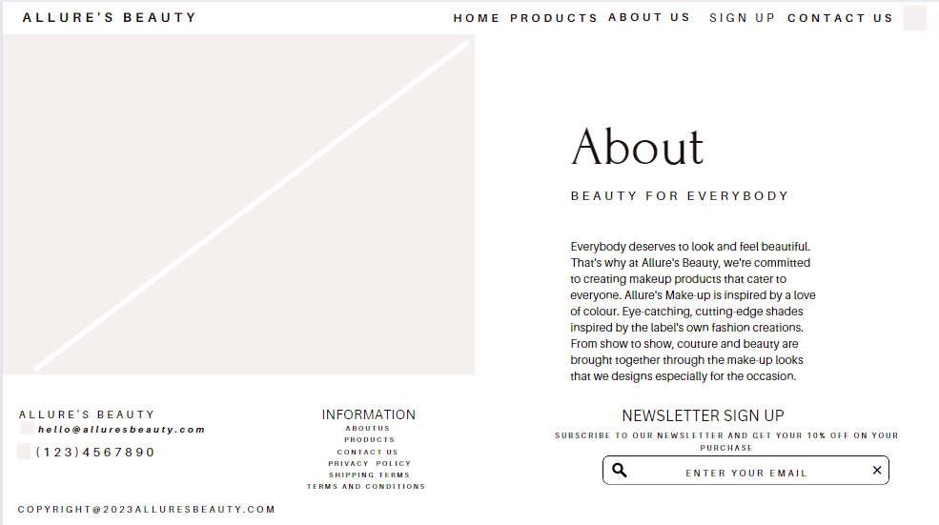

In this wireframe, the "about us" page will provide a quick overview of the services that the website and its team may provide to users.

4. Sign Up Page:

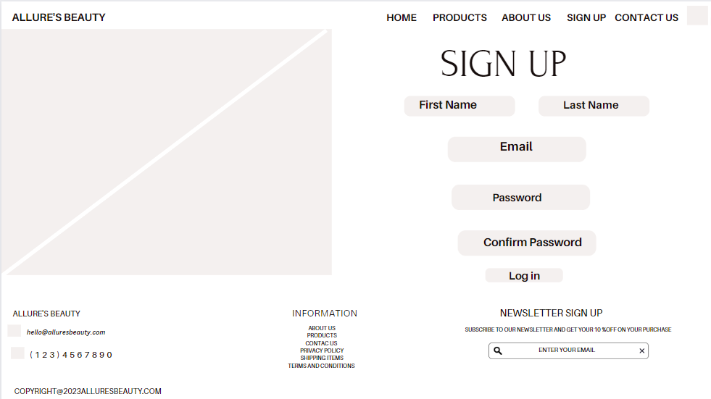

In this wire frame, there is an option for a client to sign up to our website

5. Contact Us:

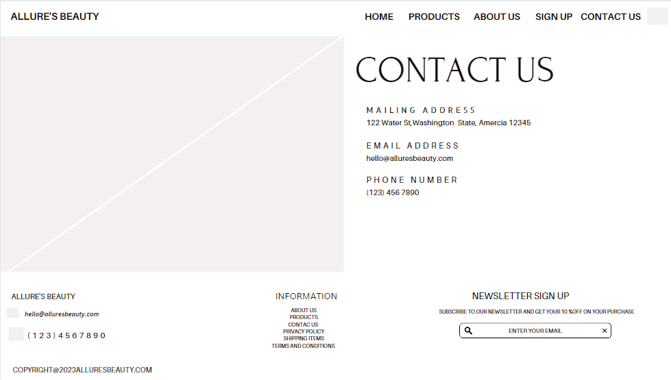

In this wireframe, we are showing that there is an option to contact us.

**2. High Fidelity Design:**

High fidelity design refers to a design process that focuses on creating detailed, fully functional prototypes of digital products or interfaces. This type of design is often used in design of the user interface (UI) and the user experience (UX), as well as in software and web development.

High fidelity design involves creating prototypes that are as close as possible to the final product in terms of both functionality and visual design. This typically involves using advanced software tools to create interactive mockups that simulate the behavior and appearance of the final product. These prototypes can include features such as clickable buttons, forms, and animations, and can be used to test and refine the design before it is implemented.

The goal of high fidelity design is to create a product that meets the needs of its users, while also being visually appealing and easy to use. By creating detailed, fully functional prototypes, designers can get feedback from users and stakeholders early in the design process, allowing them to make informed decisions about the final product.

Following are the actual UI designs of Website, how it would be looking:

* Home Page.
* Product page
* About Page
* Services Page
* Contact Us Page.

1. Home Page.

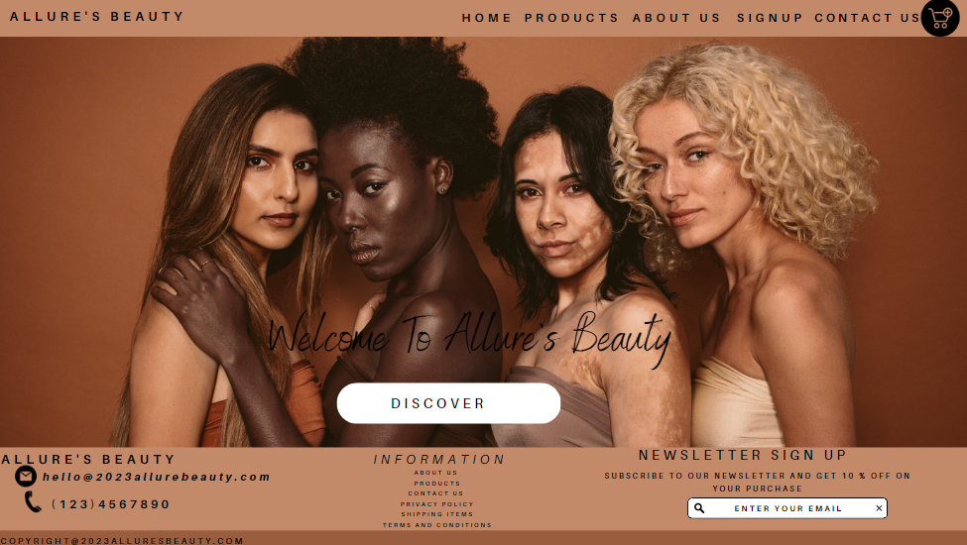

# 2. Product Page :

# C:\Users\SENIOR CIVIL JUDGE\Pictures\Screenshots\Screenshot (63).png

# 3. About Us:

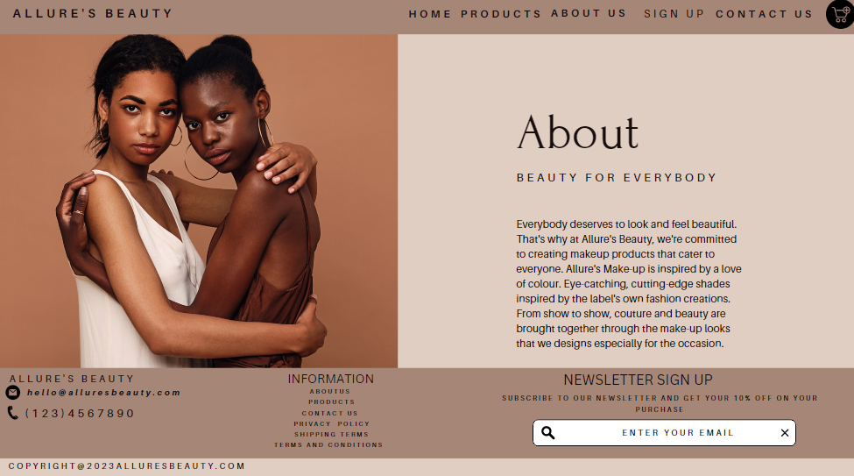

4. Sign Up Page:

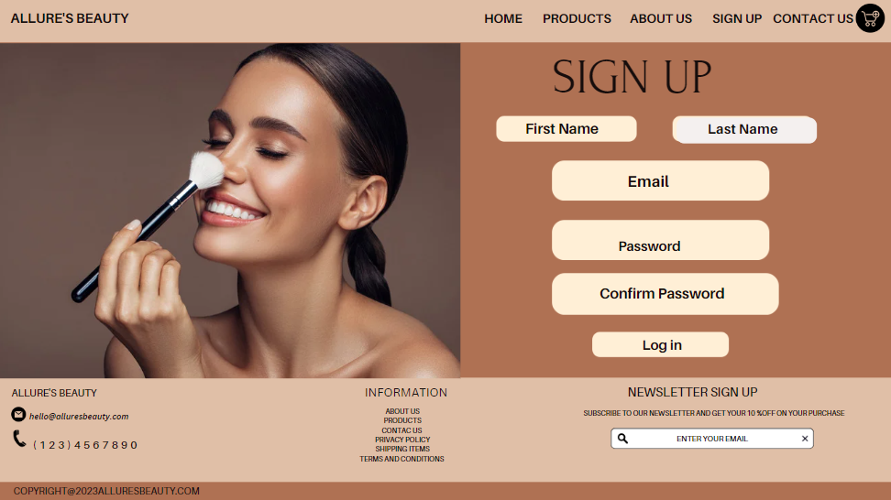

5. Contact Us Page:

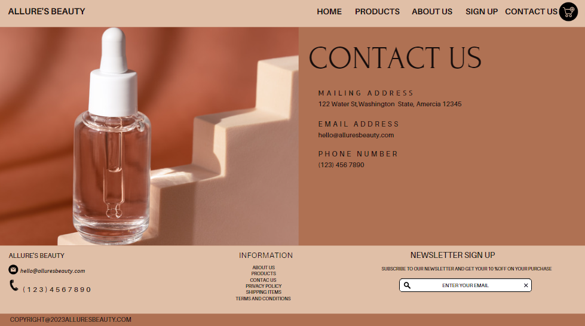

4) Site Map

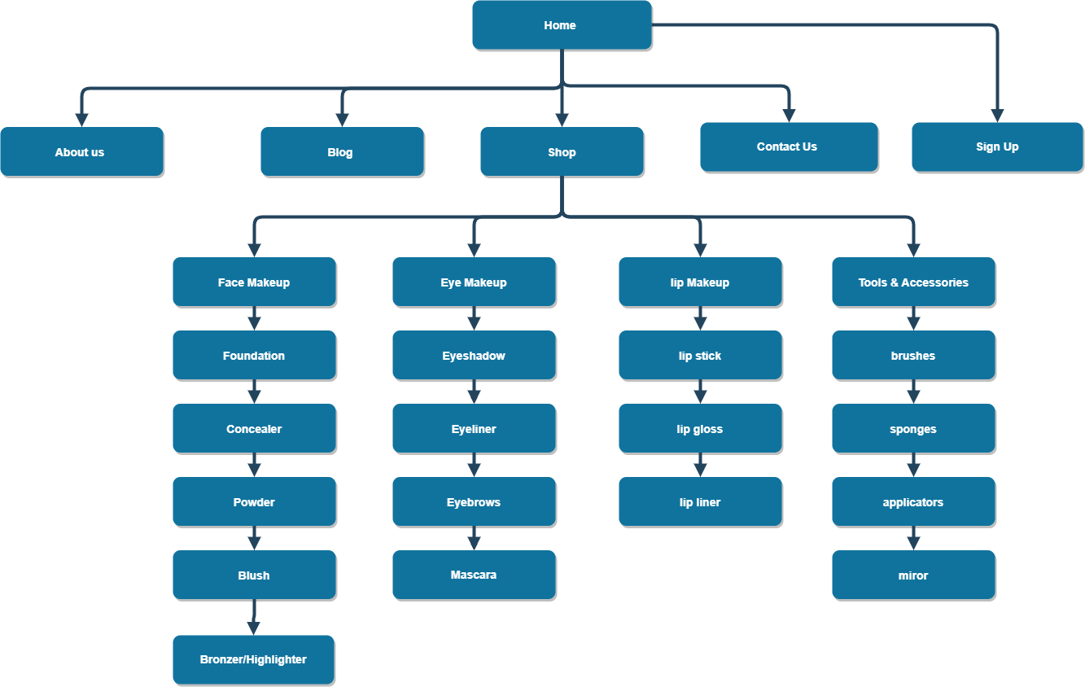

5) Accessibility And Usability:

To ensure that all users can access and utilize the site, regardless of their device, browser, or disability, accessibility and usability issues must be taken into account while building a website. Here are a few things to remember:

1 Mobile device design:

You must create a mobile-friendly website because more and more people are using their mobile devices to access the internet. Make certain that your website responds to screen sizes and is responsive.

2 Test across different browsers:

A website should be tested on many browsers because not all users will be using the same browser. This will help to assure compatibility. Think of well-known browsers such as Chrome, Firefox, Safari, and Edge.

3 Use Alternate Text In Place Of Images:

It's important to provide each image with an explanation in the form of alternative text because people with visual impairments may use screen readers to browse the internet. By doing this, you can be sure that users with visual issues will be able to understand the content on your website.

4. Use Descriptive Headings:

Employ evocative titles to help readers understand the hierarchy and organizational structure of your content. To make it simpler for customers to navigate and comprehend your website, employ informative headings.

5. Offer Keyboard Navigation Options:

Some users might not be able to use a mouse, so it's crucial to provide them that choice.

This enables users to use just their keyboards to navigate your website.

6. Choose Legible And Simple Fonts:

Some readers can find it difficult to read small or elaborate fonts. To ensure that all readers can read and comprehend your material, select legible and easy-to-read fonts.

You may design a website that is accessible to and useable by all users by keeping these accessibility and usability considerations in mind.

**Section 2**

**CLIENT-SIDE TECHNOLOGIES:**

A group of computer languages, instruments, and frameworks known as client-side technologies run in the user's web browser or on the client-side. They are used to build dynamic, interactive web pages that react to user input without necessitating a complete page refresh.

Popular client-side tools include:

1. HTML

2. CSS

3. BOOTSTRAP

4. JAVASCRIPT and others

For my website I will mainly be using these four client-side technologies that are further explained below.

**HTML (Hyper Text Markup Language):**

HTML is the most popular markup language for building and classifying web content (Hypertext Markup Language). It is a language that defines the structure of a web page and allows programmers to incorporate various forms of multimedia, such as pictures, videos, and music. The various components on a web page, including headings, paragraphs, links, and forms, are defined by a collection of markup tags in HTML. It serves as the foundation of the internet and is used to build both static and dynamic web apps. Users of different devices and browsers can access visually appealing and interactive web sites made with HTML by developers.

In addition, HTML serves as the basis for other web tools like JavaScript and Cascading Style Sheets (CSS). While JavaScript is used to add functionality and interactivity to web sites, CSS is used to style the text of web pages. To create dynamic, responsive web pages that adjust to various screen sizes and devices, HTML works in conjunction with CSS and JavaScript.

New versions of HTML with improved features are regularly published because the language is constantly changing. HTML5 is the most recent version of HTML, and it adds new components and capabilities like semantic markup, support for music and video, and new form controls.

Example of HTML is provided below.

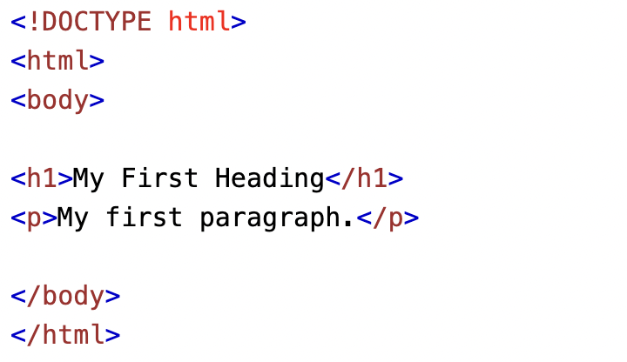

Source: w3school

CSS (Cascading Style Sheets):

CSS (Cascading Style Sheets) is a language for creating style sheets that define how HTML documents should look and be laid out. In order to design responsive and aesthetically pleasing online pages, it is combined with HTML. It is simpler to control and update a website's style and layout thanks to CSS, which enables developers to separate the information of a web page from its presentation.

The way CSS functions is by defining a collection of guidelines or styles that are applied to various web page elements. Font styles, hues, background images, and spacing are a few examples of these styles. Additionally, CSS enables programmers to create responsive designs that adjust to various screen sizes and devices, enhancing the usability and accessibility of web sites.

Because CSS is so adaptable and flexible, it's simple to develop distinctive designs for websites and web apps. Additionally, it offers a range of layout choices, such as grid and flexbox, that make it simple for developers to make intricate and responsive layouts.

In conclusion, CSS is an essential part of web development and is used to make websites and web apps that are both aesthetically pleasing and user-friendly. It gives programmers the freedom and tools they need to make original, responsive site designs.

Example of CSS:

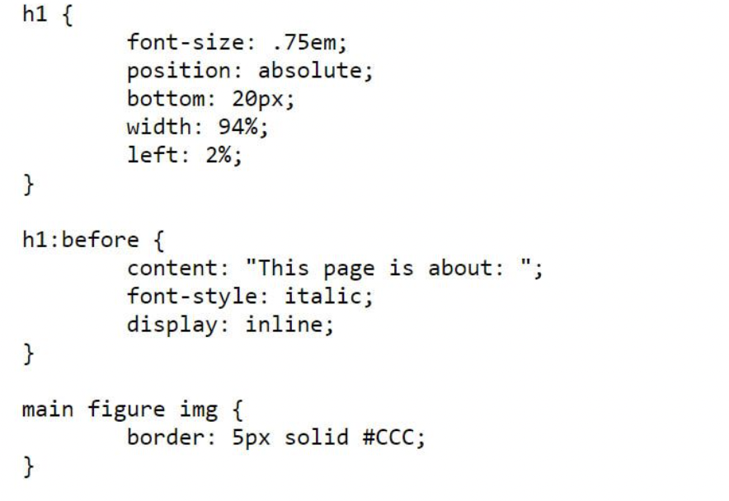

Source: w3school

The style, layout, and wireframes we produced in stage 1 will be applied using CSS: High level planning, and we'll use a range of methods to get there. For example, the code below generates a navigation panel. To explicitly address them or how our design requires us to format them, we'll give our HTML components an Id and a Class.

Before CSS:

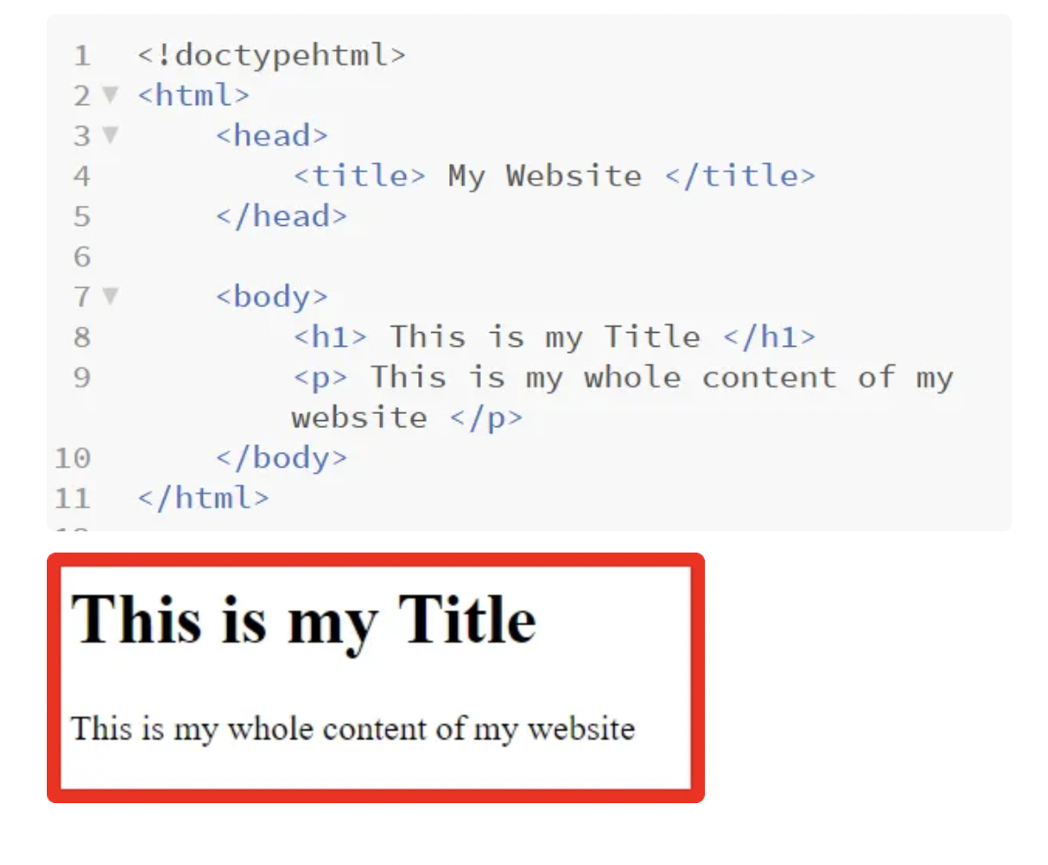

After CSS:

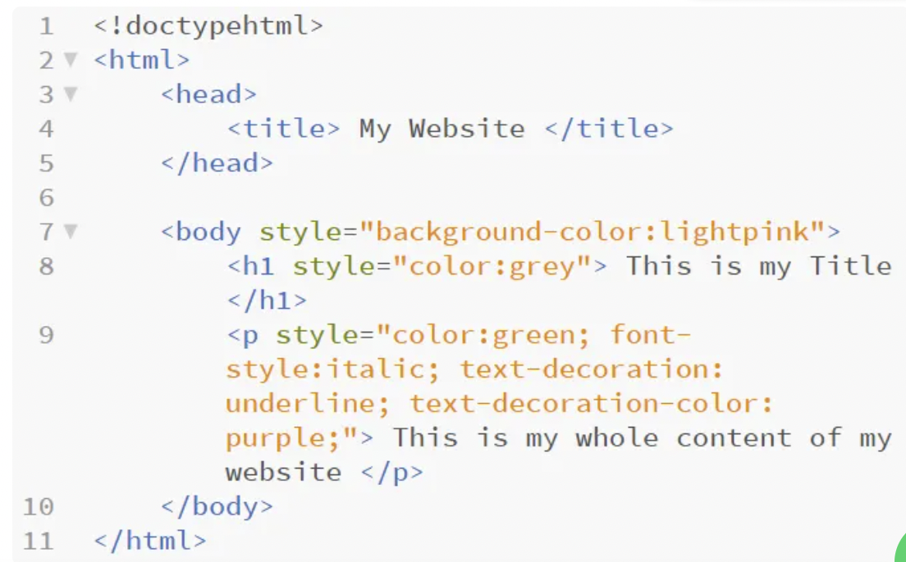

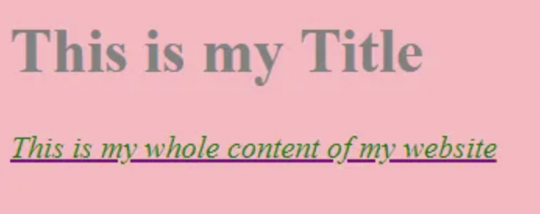

This is just an example how CSS and html would work out for my website.All the designs format would be styled in CSS with the help of HTML.

3.BOOTSTRAP:

A well-liked open-source front-end system called Bootstrap is used to create mobile-first and responsive web apps. It is a set of HTML, CSS, and JavaScript development tools that make it simple and fast for programmers to make contemporary and aesthetically pleasing webpages and apps.

Developers can create web apps using a variety of pre-designed Bootstrap components and themes, including icons, forms, and navigation bars. These components are adaptable, enabling developers to modify them to meet their unique demands and aesthetic specifications.

The flexible design of Bootstrap is one of its main advantages. Developers can build web apps using Bootstrap that appear fantastic on desktops, tablets, and cellphones. Fluid grids, adaptable layouts, and responsive media queries are used by Bootstrap to create its mobile design.

Additionally, Bootstrap comes with a substantial collection of JavaScript modules that can be used to enhance the usefulness and interactivity of web sites. These plugins make it simple for developers to incorporate these components into their online apps by offering features like modals, carousels, and tooltips.

Overall, Bootstrap is a strong and adaptable front-end system that gives programmers the ability to swiftly and simply build responsive and aesthetically pleasing web apps. It is a well-liked option for web development tasks of all kinds due to its broad selection of pre-designed components, responsive design, and JavaScript extensions.

Example of Bootstrap:

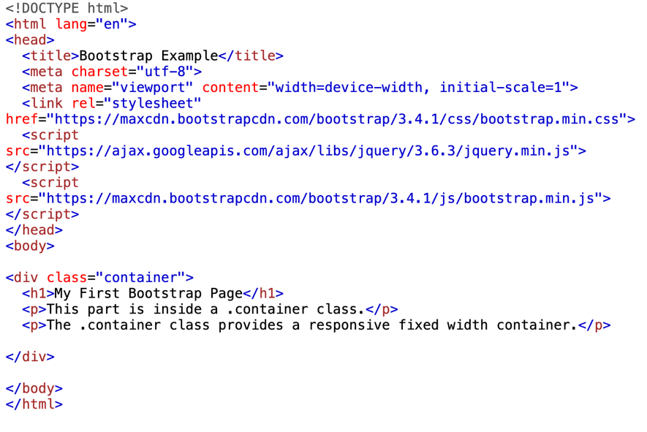

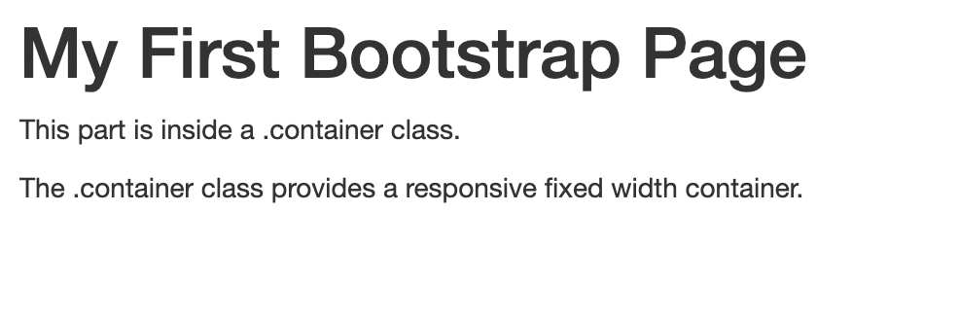

Source : w3school

4. JAVASCRIPT:

Programming language JavaScript is mainly employed in web creation. online browsers use this high-level, interpreted language to enhance the usefulness and engagement of online sites. JavaScript enables programmers to alter the behaviour and content of a web website in order to build dynamic and adaptable web apps.

Form validation, animating web page components, and sending AJAX requests to server-side APIs are just a few of the many uses for JavaScript. Complex web apps with dynamic user interfaces and real-time data changes can also be created using it.

The capacity of JavaScript to communicate with HTML and CSS is one of its primary characteristics. It is possible to build dynamic and responsive user interfaces by using JavaScript to dynamically change the content and design of web sites. Developers can build intricate and engaging web apps by using JavaScript to automatically construct and modify HTML components and CSS styles.

On the server side, JavaScript is also utilised and is referred to as Node.js. The client-side and server-side components of web apps can be integrated seamlessly thanks to Node.js, which enables programmers to build server-side applications using JavaScript.

Example of JavaScript:

JavaScript’s work with HTML and CSS

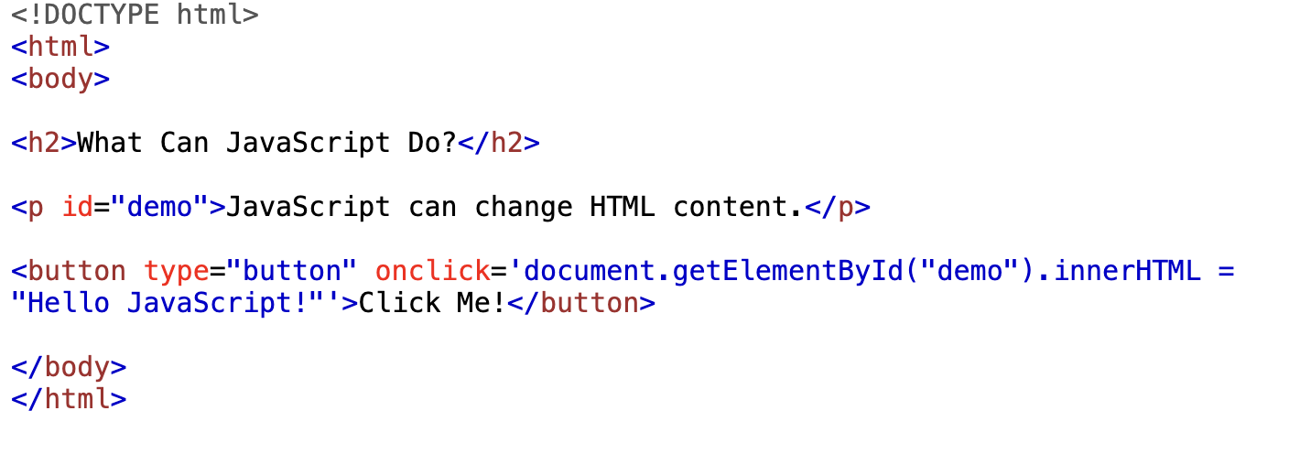

Overall, JavaScript is an indispensable computer language for web creation because it is flexible and strong. It is essential for creating contemporary and responsive web apps because it can work with HTML and CSS, control the content and behaviour of web pages, and operate on both the client-side and server-side.

Section 3

**Server Side Technologies:**

Server-side technologies are essential to the creation of websites because they allow for the storage, processing, and retrieval of data. Among the often employed server-side technologies are:

1 Languages for writing server-side scripts:

Programmers can build dynamic web pages that interact with databases and other server-side resources using server-side scripting languages like PHP, ASP.NET, and Java Server Pages (JSP). The final web page that is transmitted to the client's browser can be created on the server using these languages that can be integrated into HTML code.

2 Web application frameworks:

By supplying pre-built components and modules for managing tasks like database access, routing, and authentication, web application frameworks like Ruby on Rails, Django, and Laravel give an organized approach to web application development.

3 Data Bases:

To store and retrieve data for web applications, server-side databases like MySQL, Oracle, and MongoDB are used. They give programmers the ability to organize data in a structured way and run sophisticated queries to extract data as required.

4 CMSs, or Content Management Systems:

Offer pre-made themes and tools for maintaining and developing website content. Examples of CMSs include WordPress, Drupal, and Joomla. They make it possible for non-technical individuals to edit website content without having to know how to code.

In conclusion, server-side technologies are essential to the creation of dynamic, data-driven websites that are scalable and safe by providing the necessary tools and infrastructure.

1 PHP:

PHP (Hypertext Preprocessor) is a server-side scripting language used for creating dynamic web pages and applications. It was created in 1994 by Rasmus Lerdorf and is now maintained by The PHP Group. It is an open-source language and is widely used for web development due to its flexibility, ease of use, and compatibility with different platforms.

PHP code is executed on the server-side, which means that the server runs the code and generates HTML code that is then sent to the client-side browser for display. This makes PHP a popular choice for building dynamic websites that can interact with databases and provide personalized content to users.

PHP is often used in conjunction with other web technologies like HTML, CSS, and JavaScript to build full-stack web applications. It also has a large and active community of developers, which means that there are many resources available for learning and troubleshooting.

Some of the features of PHP include:

* Compatibility with different operating systems and web servers
* Support for different databases, including MySQL and PostgreSQL
* Built-in functions for handling strings, arrays, and other data types
* Object-oriented programming support
* Integration with different web technologies like XML and JSON

Overall, PHP is a powerful and flexible language that is well-suited for web development. Its popularity and wide adoption make it a valuable skill for web developers to learn.

Here are some examples of PHP:

1. Hello World Program:

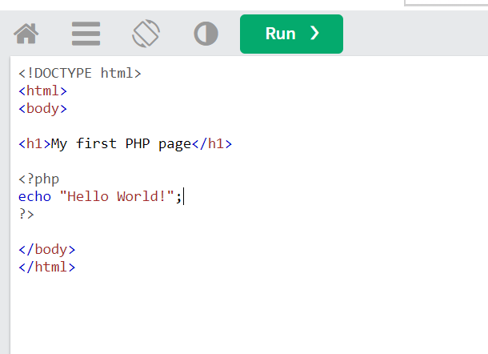

1. Variables :

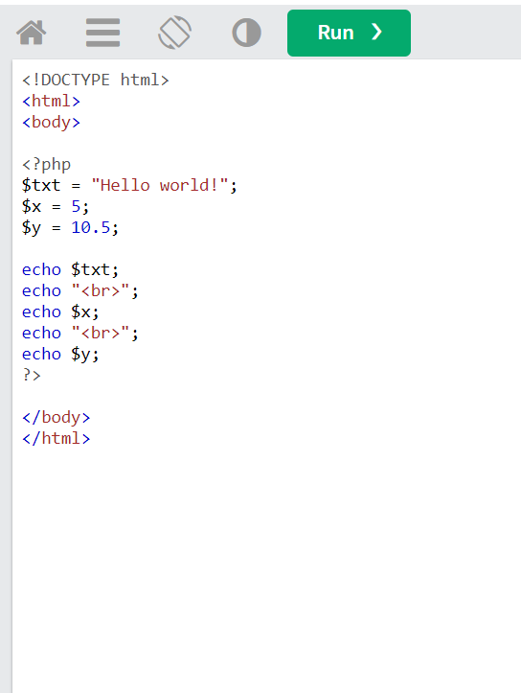

1. Echo / Prints:

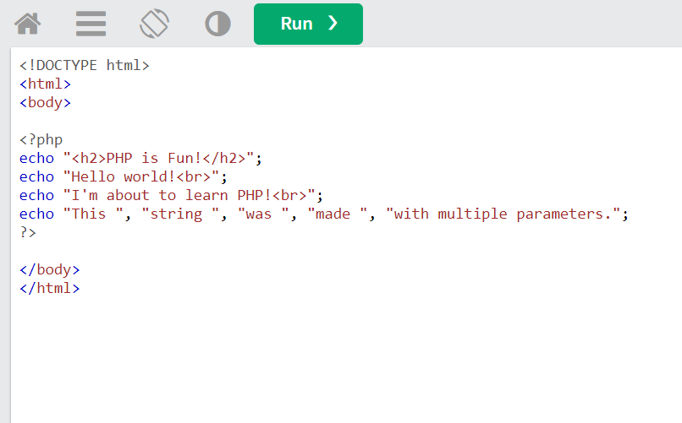

2. PHP SESSIONS:

PHP session is a mechanism that enables web applications to store and access data across multiple pages or requests by the same user. A session is a way to track user's activity on a website, allowing you to remember their preferences, login credentials, and other information throughout their browsing session.

When a user visits a website that uses PHP sessions, a unique session ID is generated and stored in a cookie on the user's computer. This ID is used to identify the user's session and retrieve their data as they navigate through the website.

Sessions are typically used to store user-specific data such as user ID, login status, shopping cart contents, and other personalized settings. This data can be accessed and manipulated through the $_SESSION global variable in PHP.

The process of creating a session involves a few basic steps:

1. Starting a new session using the session_start() function.
2. Storing data in the $_SESSION superglobal array.
3. Retrieving data from the $_SESSION superglobal array.
4. Destroying the session using the session_destroy () function when the user logs out or closes their browser.

It's important to note that sessions are vulnerable to session hijacking and other security threats if not implemented properly. To prevent these issues, developers should use secure session management techniques such as using SSL encryption, generating strong session IDs, and validating user input.

Overall, PHP sessions provide a convenient and powerful way to store user data across multiple pages and requests, making it an essential tool for building dynamic web applications.

Here are some examples of using PHP sessions:

1. Starting a Session:

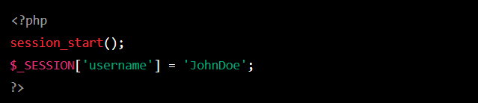

In this example, we are starting a new session and setting a session variable called 'username' with the value 'JohnDoe'. The session_start () function must be called before any output is sent to the browser

1. Using Sessions to Track User Login:

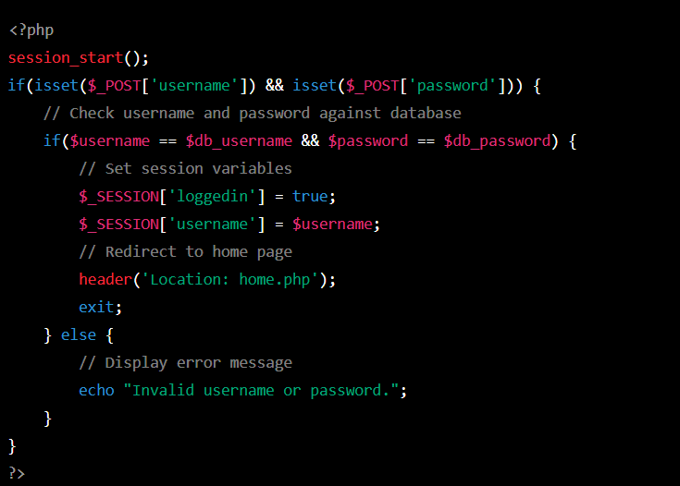

In this example, we are using sessions to track whether a user is logged in or not. When the user submits their login credentials, we check them against the database. If the login is successful, we set the 'login in' and 'username' session variables, and redirect the user to the home page. If the login fails, we display an error message.

3. JSONS:

JSON (JavaScript Object Notation) is a lightweight data-interchange format that is easy for humans to read and write and easy for machines to parse and generate. It is commonly used for transmitting data between a server and a web application as an alternative to XML.

JSON data is represented as key-value pairs, similar to a dictionary in Python or an object in JavaScript. The keys are strings, and the values can be a variety of data types, including strings, numbers, booleans, arrays, or other JSON objects. JSON also supports nested data structures, making it a versatile format for representing complex data.

Here's an example of a simple JSON object:

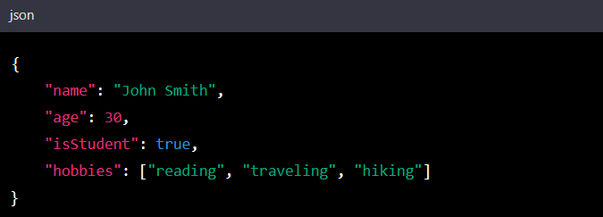

In this example, the object has four key-value pairs. The **"name"** key has a string value of **"John Smith"**, the **"age"** key has a numeric value of **30**, the **"isStudent"** key has a Boolean value of **true**, and the **"hobbies"** key has an array value containing three string.

4 .Technologies Used:

Let's look at each of these technologies separately to better understand how they are used to process user input, save and retrieve data, and create dynamic content. These technologies include JSON, super global, forms, views, and HEREDOC.

A server and client can exchange data using the lightweight JSON (JavaScript Object Notation) data interchange format. It is the best format for data transport because it is text-based and simple to read and write. When developing websites, JSON is frequently used to transport data from a web application to a server. The json encode and json decode methods in PHP can be used to convert PHP data to JSON and vice versa.

In a PHP script, super globals are predefined variables that are accessible in all scopes. These variables, which include $_GET, $_POST, and $_COOKIE, hold details about the current request and its surroundings, as well as the user's input. These super globals can be used to retrieve user input data and handle it appropriately.

Forms are HTML elements that allow users to input data into a web application. When a user submits a form, the input data is sent to the server for processing. In PHP, you can retrieve form data using the $_POST super global. You can then use this data to perform various operations, such as inserting data into a database or generating dynamic content.

The presentation layer of an application is referred to as views in web development. In accordance with information obtained from a database or other sources, views are in charge of producing HTML output. By using the HEREDOC syntax to embed PHP code within HTML, views in PHP can be used to create dynamic content. When you declare a string in PHP using the HEREDOC method, you can directly include variables and PHP code within the string.

In conclusion, these technologies are used in conjunction to create dynamic content for web applications, handle user input, and store and retrieve data. Views are used to create HTML output based on data retrieved from a database or other sources, JSON is used to exchange data between a client and server, superglobals are used to retrieve user input data, forms are used to let users enter data into a web application, and HEREDOC syntax is used to embed PHP code within HTML strings.

6. Personalized Contents And Services to User:

Server-side processing can enable a website to provide personalized content and services to users in a variety of ways. Here are some examples:

1. User Authentication and Authorization: With server-side processing, a website can authenticate and authorize users before allowing them access to personalized content and services. This can include personalized recommendations, customized preferences, and personalized user experiences.

1. Dynamic Web Pages: Server-side processing allows for dynamic web pages that are generated based on user inputs, preferences, and data. This can include personalized recommendations, customized search results, and targeted advertising based on user behavior.
2. Customized Content Delivery: With server-side processing, a website can deliver customized content to users based on their browsing history, location, language preferences, and other relevant data. For example, an e-commerce website can suggest products based on a user's past purchases or browsing history.
3. User Tracking and Analytics: Server-side processing can enable user tracking and analytics, allowing website owners to gain insights into user behavior, preferences, and trends. This information can be used to personalize content and services and improve the user experience.
4. E-commerce Personalization: With server-side processing, an e-commerce website can personalize the shopping experience for each user, including personalized recommendations, customized search results, and targeted advertising based on user behavior.

Overall, server-side processing is essential for providing personalized content and services to users, as it enables websites to process and analyze user data and generate dynamic, customized web pages and content.

**Section 4**

**International Communications Protocols:**

International communications refers to the exchange of information and ideas between individuals, organizations, or nations across international borders. This can include various forms of communication such as written, verbal, or digital.

International communication can take place between individuals, businesses, governments, non-governmental organizations, and other entities located in different countries. The purpose of international communication can vary widely, from personal to professional, cultural, educational, or political.

In today's globalized world, international communication has become increasingly important, as it plays a vital role in fostering understanding and cooperation between different countries and cultures. It enables people to exchange ideas and knowledge, form alliances and partnerships, and work together towards common goals.

1 HTTP:

HTTP stands for Hypertext Transfer Protocol. It is a protocol used for communication between web servers and web clients (such as web browsers). When you type a website address into your web browser, it sends an HTTP request to the web server hosting that website. The web server then responds to the request with an HTTP response, which contains the web page content that the browser can render for the user.

HTTP is the foundation of the World Wide Web and is responsible for the exchange of information between web servers and web browsers. The protocol defines how messages are formatted and transmitted and what actions web servers and browsers should take in response to various commands. HTTP is a stateless protocol, which means that each request and response are independent of any previous requests and responses.

Here are some examples of HTTP:

1. Accessing a website: When you type a website URL into your browser, your computer sends an HTTP request to the server hosting that website, asking for the website's HTML code. The server then responds with an HTTP response containing the HTML code, which is then rendered by your browser.

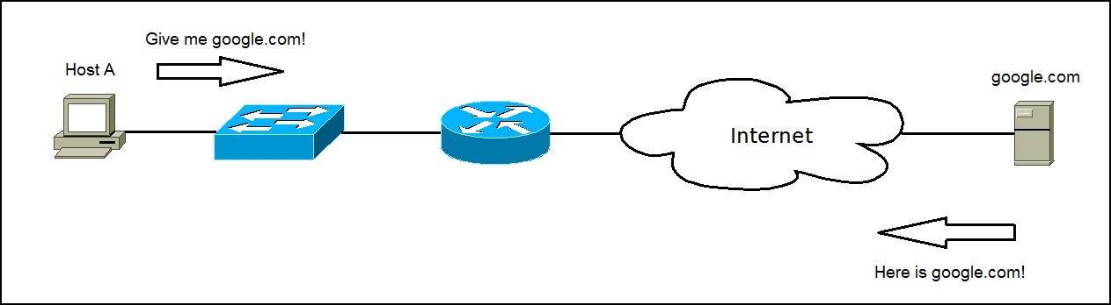

1. Submitting a form: When you fill out a form on a website and click the "submit" button, your browser sends an HTTP request to the server with the data you entered. The server then responds with an HTTP response indicating whether the submission was successful or not.

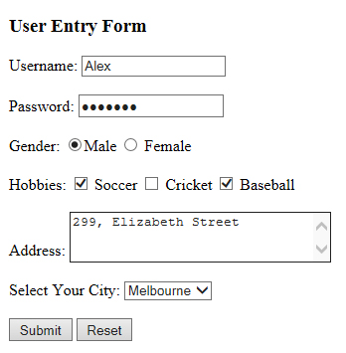

1. Downloading a file: When you download a file from the internet, your browser sends an HTTP request to the server hosting the file, asking for the file to be downloaded. The server then responds with an HTTP response containing the file data, which is then downloaded to your comput

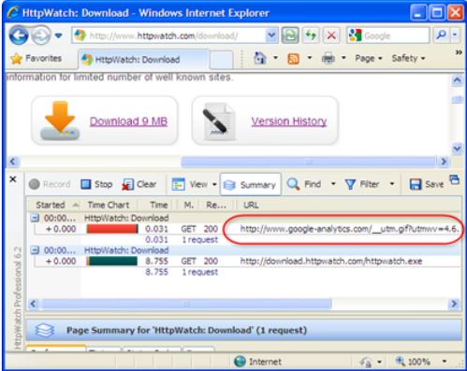

1. API requests: Many websites provide APIs (Application Programming Interfaces) that allow developers to interact with their services. To use an API, a developer sends an HTTP request to the API endpoint with the required parameters, and the server responds with an HTTP response containing the requested data.
2. AJAX requests: AJAX (Asynchronous JavaScript and XML) is a technique used to make web pages more responsive by asynchronously requesting data from a server without reloading the entire page. AJAX requests are made using HTTP requests and responses.

2. HTTPS:

HTTPS stands for "Hypertext Transfer Protocol Secure." It is a protocol used for secure communication over the internet. It provides a way for websites to encrypt the data that is transmitted between the user's browser and the website's server, making it more difficult for hackers and others to intercept and read the data.

When you visit a website that uses HTTPS, you will notice that the URL begins with "https://" instead of "http://". This indicates that the connection between your browser and the website's server is secure. In addition to encrypting the data, HTTPS also provides authentication, which ensures that you are communicating with the intended website and not an impostor.

HTTPS is commonly used for websites that handle sensitive information such as passwords, credit card numbers, and personal information.

Here are a few examples of using HTTPS (Hypertext Transfer Protocol Secure) with coding:

1. Python:

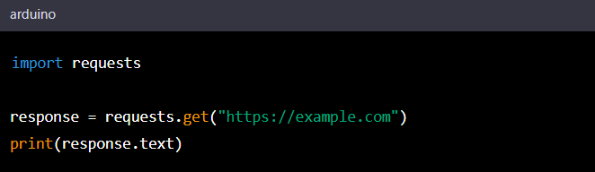

Here, we are using the **requests** library in Python to make an HTTPS request to the **example.com** website. The “**response.text’** line will print the HTML content of the website to the console.

2. JAVA SCRIPT:

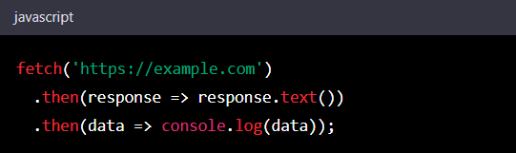

Here, we are using the’ **fetch()** ’function in JavaScript to make an HTTPS request to the **example.com** website. The response content is then logged to the console.

3. SMPT: SMTP stands for Simple Mail Transfer Protocol, which is a standard protocol used for sending email messages between servers. It is the most commonly used protocol for sending email messages over the Internet. When you send an email, your email client or application communicates with your email server, which then uses SMTP to send the email to the recipient's email server. The recipient's email server then delivers the email to the recipient's inbox. SMTP is a text-based protocol, which means that the messages are transmitted in plain text. It uses a set of commands and responses to communicate between servers. The standard port for SMTP is 25, but there are other ports, such as 587, that can be used for secure SMTP communication.

Here are some examples of SMTP usage:

1. Sending email: SMTP is primarily used for sending email from one email server to another. For example, when you send an email from your Gmail account to someone else's email address, your email client uses SMTP to send the message to the recipient's email server.
2. Receiving email: SMTP is also used for receiving email. When someone sends you an email, their email client uses SMTP to send the message to your email server.
3. Email forwarding: SMTP is used for forwarding email messages from one email server to another. For example, if you set up email forwarding from your work email to your personal email, SMTP is used to forward the messages from your work email server to your personal email server.
4. Bulk email sending: SMTP is used by businesses and marketers to send bulk email messages to a large number of recipients. This is often done using specialized email marketing software that uses SMTP to send the messages.
5. Authentication: SMTP can also be used for email authentication, such as verifying that an email message was sent by an authorized sender. This is done using techniques like SPF (Sender Policy Framework) and DKIM (Domain Keys Identified Mail), which use SMTP to include authentication information in email headers.

Here are some examples of SMTP with coding:

1. Sending an email using Python:

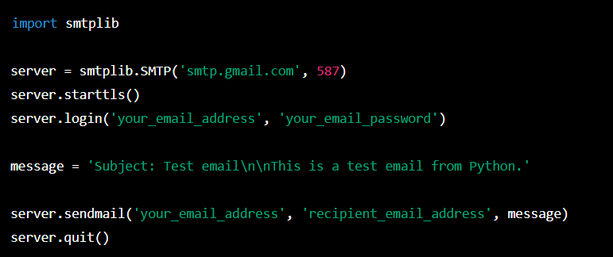

This code connects to Gmail's SMTP server on port 587, starts a TLS connection, logs in using your email address and password, creates a message with a subject and body, and sends it to the recipient's email address.

1. Configuring SMTP settings in PHP:

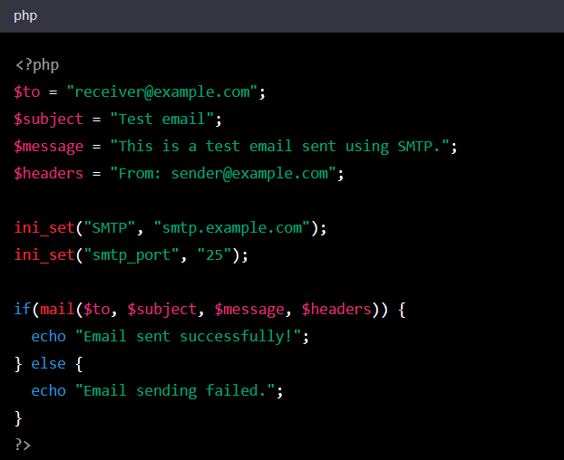

The "ini set()" method is used in this PHP example to set the SMTP server and port for the email. The email message is sent to the recipient's email address using the "mail()" method.

1. DNS:

The domain name system is known as DNS. It is a system that converts domain names that can be read by humans, such "google.com," into the IP addresses that computers use to communicate online, like "216.58.194.174."

Users can reach webpages and other internet resources by using human-readable names rather than IP addresses thanks to the hierarchical, distributed naming system known as DNS. The system uses a network of servers to store and distribute DNS records, which are data files that include domain names and the IP addresses that go with them.

Your computer sends a request to a DNS resolver, which looks up the IP address associated with the domain name, when you type a website URL into your browser. A connection between your browser and the web server hosting the webpage is then made possible by the resolver sending that IP address back to your machine.

Here are some instances of DNS usage:

1. When you enter the domain name of a website into your browser, DNS is used to find the IP address associated with that domain name so that the browser may establish a connection to the website.

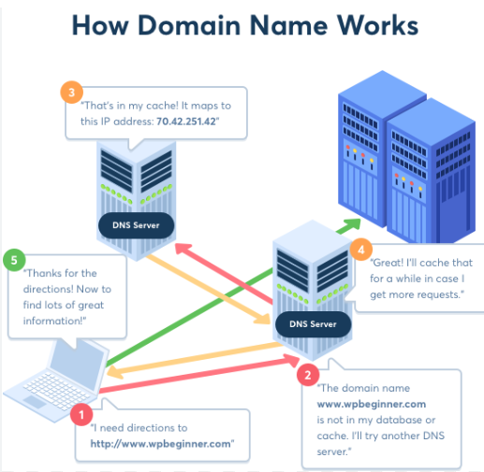

2. The email client utilizes DNS to find the IP address of the email server that processes emails for the recipient's domain when you send an email.

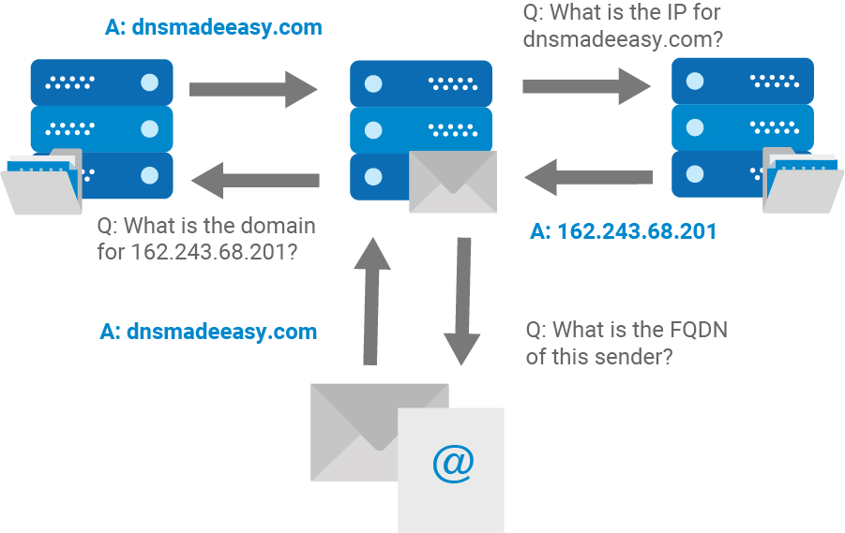

1. FTP:

The term "File Transfer Protocol" refers to a common protocol used to transfer files over the internet. It is a client-server protocol, so a client software sends the request for a file transfer, and a server programme reacts to the request by sending the files.

FTP is frequently utilized to upload and download files to and from a remote server or website. It can also be used to move files among computers connected to a local network. Users can browse remote directories and control file transfers using a command-line interface or graphical user interface (GUI), which is how FTP is commonly done.

The command channel and the data channel are the two channels that FTP uses for communication. The data channel is used to transport the actual file data, while the command channel is used to convey commands and receive responses from the server. To enable safe file transfers, FTP also supports a number of authentication and encryption techniques.

Here are a example of FTP usage:

1. Uploading website files: Many website owners use FTP to upload their website files to their web hosting provider's server. This allows them to make changes and updates to their website from anywhere with an internet connection.

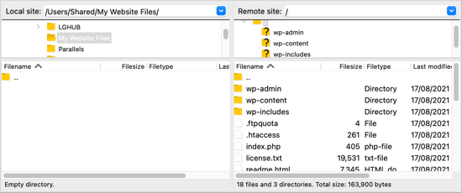

Use Ftp to upload files to Word Press.

1. TCP IP:

A group of communication protocols called TCP/IP (Transmission Control Protocol/Internet Protocol) are used to link devices together on the internet. It is in charge of sending data packets between computers and is the most widely used protocol for data transfer on the internet.

TCP is in charge of breaking up the data into smaller packets, sending them across the internet, and making sure they reach at their destination in the right order in order to build a dependable and error-free connection between two devices. It also makes sure that any packets that are lost or damaged are sent again.

On the other side, IP is in charge of distributing data packets among internet-connected devices. Each device is given a special IP address, which makes it easier to recognize it on the network and guarantees that packets are sent to the right place.

TCP/IP together offers a standardized method for devices to connect with one another online, enabling the seamless movement of data between various networks and gadgets..

TCP/IP examples include the following.

1. HTTP (Hypertext Transfer Protocol), the internet protocol used to send web pages.

2. FTP (File Transfer Protocol) is the internet protocol used to transfer data.

3. SMTP, or Simple Mail Transfer Protocol, is the internet protocol used to send email messages.

4. The technology used to convert domain names into IP addresses is called DNS (Domain Name System).

5. DHCP (Dynamic Host Configuration Protocol), which assigns IP addresses to networked devices.

6. The mechanism used to ensure dependable data transmission between devices over the internet is called TCP (Transmission Control Protocol).

7. IP (Internet Protocol) is the protocol used for internet-based data packet routing between devices

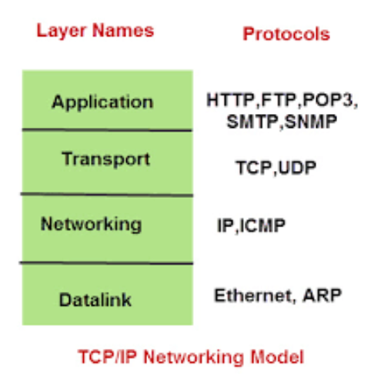

Protocols That Website Using:

Several protocols are used in the construction of websites in order to facilitate communication between web servers and clients (i.e., web browsers). The following represent a few of the main protocols used to build websites:

* 1. Data is requested and transferred between a client and a server using the HTTP (Hypertext Transfer Protocol) protocol. The World Wide Web's data communication is built on HTTP.
  2. The structure and content of web pages are produced using HTML (Hypertext Markup Language). The structure and elements of a web page are described using this markup language.
  3. CSS (Cascading Style Sheets): CSS is used to provide HTML elements style and visual formatting. It enables web designers to produce appealing and user-friendly designs for their websites.
  4. JavaScript is a computer language used to develop dynamic and interactive features for web pages. It can be used to develop interactive features such as animations and form validation.
  5. File transfers between a client and a server are done using the FTP (File Transfer Protocol) protocol. It's frequently used to transfer files to and from a web server. DNS (Domain Name System): DNS converts domain names that can be read by humans (like www.example.com) into IP addresses, which computers use to recognize one another on the internet.

Together, these protocols make it possible to build and run websites.

**Conclusion:**

**In conclusion, our makeup offers a wide range of high quality make up products and beauty tips for makeup enthusiasts. We strive to an enjoyable and convenient online shopping experience, with user friendly navigation, detailed products descriptions and secure payment options. Our website also serves as a valuable resource of beauty inspiration and education, with tutorials, reviews and articles on the latest makeup trends and techniques. We are committed to customer satisfaction and continuously improving our valued customers. Whether you are a makeup novice or an experienced beauty enthusiasts, we hope our website serves as your go to destination for all things make up. Shop with us today and enhance your beauty with confidence!**